 | Assignment No. 1  Semester: Fall 2026  CS201P – Introduction to Programming(Practical) |  | Total Marks: 20  Due Date: November 06, 2026
Instructions
Please read the following instructions carefully before submitting the assignment:
It should be clear that your assignment will not get any credit if:

- Assignment is submitted after the due date.
- Submitted assignment does not open or file is corrupt.
- Assignment is copied (From the internet/students).
- Assignment is submitted in any file format other than .cpp.

Recommended tool to develop Assignment
- Dev C++

Objectives:
To enable students to understand and practice the concepts of:
- Variables
- Constants
- Data types
- Arithmetic operators
- Conditional statements
- Output statements
- Iterative statements

Assignment Submission Instructions

You must submit only a .cpp file on the assignments interface of CS201P from your LMS account. Assignments submitted in any other format(image, pdf, doc, docx, rar, zip etc) will be given zero marks. So, check your solution file format before submission.

For any query related to the assignment, please contact CS201P@vu.edu.pk.

Assignment

Problem Statement
Write a C++ program that simulates a Community Water Refill Depot billing system. Your program must hard-code your own VU Student ID and name. A water refill depot fulfills five customer orders in a day. Each order is for a particular water package, and the program calculates the bill, applies a quantity discount, and classifies the daily sales.

Detailed Requirements

Step 1 – Student Information
Hard-code your full name and VU Student ID (e.g., BS123456789) directly in the program.
Display both before any other output.
No user input is taken anywhere in the program.

Step 2 – Transactions
The depot fulfills five customer orders each day. Extract the last five digits of your student ID.

You must use the modulus (%) and division (/) operators to extract the last five digits of your student ID's numeric part.

Example: If the numeric part of your student ID is 123456789, you must extract the last five digits, which are 5, 6, 7, 8, and 9 (the 5th, 6th, 7th, 8th, and 9th digits from the left).

Use each digit for one order and multiply that digit by 10 to determine the quantity (number of containers) for that order. The first three orders are 5-litre containers, while the last two orders are 19-litre containers.
The charges are:
- 5-litre container: Rs. 70 per container
- 19-litre container: Rs. 180 per container
Calculate the original charge for each transaction using the rate for its category.

Suppose the extracted digits are 5, 6, 7, 8, and 9. The quantities, Package type, and original charges will be calculated as follows:

Extracted digits | Quantity | Package type | Original Charges
5 | 5*10=50 | 5-litre container | 50*70= 3500
6 | 6*10=60 | 5-litre container | 60*70=4200
7 | 7*10=70 | 5-litre container | 70*70=4900
8 | 8*10=80 | 19-litre container | 80*180=14400
9 | 9*10=90 | 19-litre container | 90*180=16200

Step 3 – Discount
An order receives a 10% discount if it contains 50 or more containers. Otherwise, no discount is applied.
For every transaction, display the quantity, package type, original charge, discount amount, and final charge.

Step 4– Status Classification
Determine the status according to the final amount collected:
- Final amount below Rs. 15,000 → LOW SALES
- Rs. 15,000 to Rs. 29,999 → NORMAL SALES
- Rs. 30,000 or above → HIGH SALES

Step 5 – Daily Summary
After all five transactions have been processed, display:
- Total containers supplied
- Total original charges
- Total discount
- Final amount collected
- Sales status

Programming Requirements
Use an iterative statement to process the five transactions. Use appropriate variables/constants, arithmetic calculations, and if/else conditions. The program must compile as a C++ .cpp file.

Expected Output Format
Your program should display output in a clear and organized manner similar to the following:

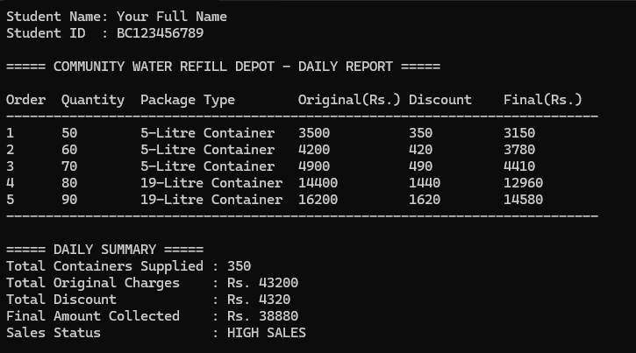

Syllabus:
The syllabus for this assignment includes all topics covered in first 3 weeks (lecture no. 1 to lecture no. 9).

Note: Remember that printf and scanf are not allowed. if you use it in the program, your marks will be deducted.
Best of luck!

